**Ruhma Ali**

**BIT-23F-015**

**Lab Task 06**

**Task#01**

Write a Python function that takes a number as input and returns the sum of its digits.

**Code:**

def sum_of_digits(number):

"""

Calculate the sum of the digits of a given number.

Parameters:

number (int): The number whose digits will be summed.

Returns:

int: The sum of the digits.

"""

# Ensure the number is positive for calculation

number = abs(number)

# Convert the number to a string to iterate through digits

return sum(int(digit) for digit in str(number))

# Example usage

number = 12345

print(f"The sum of the digits of {number} is {sum_of_digits(number)}")

**Output:**

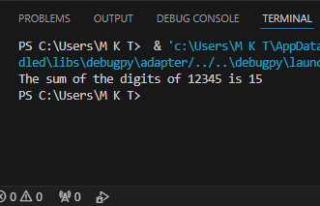

**Task#02**

Write a Python function that takes a sentence as input and returns the number of words in it.

**Code:**

def count_words(sentence):

words = sentence.split()

return len(words)

sentence = input("Enter a sentence: ")

print("The number of words in the sentence is:", count_words(sentence))

**Output:**

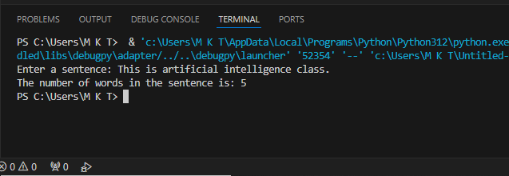

**Task#03**

Write a Python function that takes an integer and returns whether the number is even or odd.

**Code:**

def check_even_or_odd(number):

"""

Determine if a number is even or odd.

Parameters:

number (int): The input integer.

Returns:

str: "Even" if the number is even, "Odd" if the number is odd.

"""

if number % 2 == 0:

return "Even"

else:

return "Odd"

num = 42

print(f"The number {num} is {check_even_or_odd(num)}.")

**Output:**

